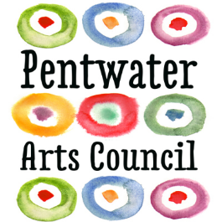

Pentwater Arts Council
Contribution Form

_____$5000(gold) ______$1000(platinum) ______$500(silver)

_____$100 ______$50 ______$25 ______Other__________________

I wish to make a contribution at the level stated above.

The donor(s) should be noted as:

Name(s)____________________________________________________________________________

Address__________________________________City___________________State______Zip________

Phone__________________________________ Email_______________________________________

My contribution is in the following category:

_____General ______In Honor Of* ______In Memory Of* _____In Appreciation Of*

*Notification Should be sent to:

Name________________________________________________________________________________

Address__________________________________City______________________State_____ Zip_______

Mail this completed form and check to the PAC Box 725 Pentwater, MI 49449

